EXHIBIT A (SOW) TO ORDER NO. X TO MASTER AGREEMENT NO. XXXXX
INTERNAL USE
CW # | xxx
Statement of Work
Between
Nationwide Mutual Insurance Company
And
Cognizant Worldwide Limited
For
Nationwide ES&S QE Services
(Mar 01’2021 till Feb 29’2024)
Prepared by | Role | Date of preparation
Robert Malinowski Jr.,  +14404135994,  Robert.MalinowskiJr@cognizant.com | Client Service Executive,  Cognizant Technology Solutions Corporation | 9/26/2020
Each of us agrees that the complete agreement between us about this transaction consists of this Statement of Work and the Order number to the Master Agreement identified above.
COGNIZANT WORLDWIDE LIMITED NATIONWIDE MUTUAL INSURANCE COMPANY
---------------------------------------------------- ------------------------------------------------------------
Authorized Signature Authorized Signature
________________________ _________________________________
Name Name
________________________ _________________________________
Title Title
________________________ _________________________________
Date Date
Signed below by Cognizant Technology Solutions U.S. Corporation (“CTS US”) solely for purposes of acknowledging that CTS US may provide local services and deliverables to Nationwide Mutual Insurance Company on behalf and at the direction of Cognizant Worldwide Limited in the United States
COGNIZANT TECHNOLOGY SOLUTIONS U.S. CORPORATION
________________________________________
Authorized Signature
________________________________________
Name
________________________________________
Title
_____________________________________
Date

TABLE OF CONTENTS

1. Overview 2
1.1 INTRODUCTION 2
1.2 background 2
1.3 SCOPE of work-project description 2
1.3.1 PROJECT SCOPE 2
1.3.2 PROJECT OUT OF SCOPE 2
1.4 SOW TYPE 2
2. Project execution approach 2
3. DELIVERABLES and Project Schedule 2
3.1 DELIVERABLES DETAILED DESCRIPTION & MILestone dates 2
3.1 SERVICE LEVEL AGREEMENTS 2
3.2 SPECIFICATION AND REQUIREMENTS 2
3.3 Assumptions and dependencies 2
4. Responsibilities 2
4.1 Supplier’S RESPONSIBILITIES 2
4.2 Customer’S RESPONSIBILITIES 2
4.3 Mutual Responsibilities 2
4.3.1 PROGRESS MEETINGS 2
4.3.2 KNOWLEDGE TRANSFER 2
5. STAFFING SCHEDULE 2
6. ACCEPTANCE and approval CRITERIA 2
7. change Management 2
8. Payment Schedule 2
9. Appendix 2

Overview

INTRODUCTION
This Statement of Work (SOW) outlines the tasks required for Cognizant Worldwide Limited 1 Kingdom Street, Paddington Central, London, W2 6BD, Registered Company Number: 07195160 (herein referred to as “Supplier” or “Cognizant”) to provide services for scaling automation and end-to-end Quality Engineering for ES&S applications and LOBs as detailed below in the scope section to Nationwide Mutual Insurance Company (hereinafter referred to as “Customer”). Supplier shall perform in accordance with this SOW, which shall be effective from 1st March 2021 until 29th February2024.
Cognizant Technology Solutions U.S. Corporation (“CTS US”) shall execute this order solely for purposes of acknowledging that CTS US may provide local services and deliverables within the United States of America to Nationwide Mutual Insurance Company on behalf and at the direction of Cognizant Worldwide Limited (“CWW”) under this order.

background
Cognizant is currently engaged in the Quality Engineering services in the ES&S area in a Managed Capacity Engagement Model having 5 onsite and 28 offshore resources. Customer has engaged 5 Non- Cognizant vendor resources to support the Quality Engineering activities along with the Customer FTEs. Cognizant is supporting 5 app-suites under the ES&S BSA.

The table below depicts the current vendor resource distribution across different app-suites

App Suite | Cognizant Resources | Non-Cognizant Resources
Private Client | Onshore: 3  Offshore: 8 | Onshore: 1
Brokerage | Onshore: 1  Offshore: 5 | Onshore: 1
Contract | Onshore: 1  Offshore: 9 | Onshore: 3
Shared Services | Onshore: 0  Offshore: 1 | Onshore: 0
MLS | Onshore: 0  Offshore: 5 | Onshore: 0

Cognizant, as part of the SOW, will provide the Quality Engineering services for the scope currently being performed by Cognizant and Non-Cognizant vendor resources mentioned above (6 onsite & 32 offshore resources), addressing the challenges as mentioned in “In Scope section 1.3.1”. Customer is looking at this engagement model, which will provide below outcomes without compromising on quality:
- Attain improved efficiency on QA spend by implementing transformation levers
- Enable end to end automation
- Offer enhanced accountability to Cognizant to deliver quality outcomes
- Process standardization and monthly metrics reporting
- Implement SLA driven accountability model after the SLA baselining during the first 6-9 months. Cognizant and customer will jointly discuss and agree on moving to SLA driven accountability, based on the maturity.
- While establishing Governance and Processes, Cognizant will work with Customer and agree to a measurable quality baseline and strive to deliver the agreed upon quality for the work Cognizant own. Cognizant will also reduce the cost of quality by transferring the Non-Cognizant vendor work to Cognizant
- Establish a flex team model for any additional activity which is beyond the capacity/scope of the core team
Cognizant planned to continue the delivery as well as the transformation work by forming two teams – Delivery Team and Transformation Team.
Primary focus of the delivery team would be to continue the current scrum activities as per the iteration/scrum plan. The delivery team will continue for the entire duration of the program. On the other hand, Cognizant will bring in the Transformation Team to implement the transformation levers (as per the transformation roadmap) over a period of 12 months. The transformation team will be off-boarded once target automation percentages are achieved by 12 months. Detailed roles and responsibilities of these two teams are provided in section 4.0

SCOPE of work-project descri ption

PROJECT SCOPE

Applications in Scope:
The below table depicts each App Suite wise Lines of Business (LOBs) and the applications which are in scope.
App Suite | LOBs in Scope | Applications In Scope
Private Client | - Personal Auto  - Home Owners  - Personal Excess  - Personal Collection | - PC InsuranceNow (UI, Forms, Rating)  - 3rd Party (ISO, MVR, CLUE)
Brokerage | - General Liability  - Liquor Liability  - Excess/Umbrella  - Property | - GW InsuranceNow (UI, Forms, Rating)  - GW InsuranceNow Datawarehouse (Staging)  - CDS-Brokerage  - 3rd Party (ISO, MVR, CLUE)
Contract | - General Liability  - Liquor Liability  - OCP Liability / Crime  - Inland Marine  - Commercial Auto (Contract)  - Personal Lines  - Garage | - ExpressConnect 2 existing and upcoming products (UI, API, Forms, Rating)  - ExpressConnect 2 APIs (Pinq, Bold penguin API)  - GW InsuranceNow Datawarehouse (Staging)  - Garage - Quote, Bind, Issue, rate calculations, form validation  - AgencyCollaboration  - ProgramsPortlet  - MPower  - Bulletins  - CATS  - Agency performance management  - Commercial Auto GW Solution (UI, Forms, Rating, Integrations)  - Personal Lines GW Solution (UI, Forms, API’s, Rating, Integrations)  - CDS-Contract / CDS-Commercial Auto
Shared Services |  | - Common Data Storage (CDS)  - ESS-Data-DM-Underwriting Performance - WINS, TIV  - ESS-Data-DM-Claims  - ESS-Data-DM-SIRIS
MLS | - Asset Management  - Excess Follow Form  - Private Company  - Private Equity  - Primary D&O | - MLS Talon  - MLS Surety Choice  ESS-Data-MLS Surety Choice

QE Services in Scope:

Day-to-Day Delivery Team:

The following activities will be supported by Cognizant’s delivery team for the ongoing projects.
- Functional / API / Integration testing & support
- Participation in Sprint planning and estimation
- Preparation of Test Strategy, obtain a customer review and sign-off
- Analysis of requirements and clarifications, if any
- Test scenarios / Test cases design for all testing types
- Test Automation Scripts Design & Execution
- Test Execution Summary reports
- Defect Reporting & Retesting Participation in Show &Tell and provide testing sign off for the current Sprint Story Cards
- End to End / Regression testing & support
- Preparation of Test Execution plan
- Test Execution and Summary reports
- Defect Reporting & Retesting
- UAT support
- UAT Test Data preparation
- Analyze UAT issues & triage
- Retest UAT Defects
- Non-Functional Testing
- Accessibility and Security Testing

Transformation Team:
During initial period of this engagement, transformation team will work to
- Review the technology landscape and define a transformation roadmap for automation
- Gather common business processes, reusable assets & dependencies
- Applications in scope for transformation scope are mentioned in Section 1.3.1.1
- The current data is provided by the customer and any changes will have impact to the schedule and cost. Based on current data Cognizant came up with projected % completion and will be baselined as part of the Transformation Roadmap
- The automatable test cases will be finalized during transformation roadmap finalization
As part of this engagement, Cognizant will deliver the Automation scripts as mentioned in the table below for all the in-scope applications identified above. Ruby automation coverage mentioned in the table is the current coverage that exists on Ruby and will be converted to TOSCA.

App Suite | Automation Area | Automation Tool | Current | Target % 6 months | Target % 9 months | Target %  12 months
Private Client | E2E Regression (Hexawise –RBT) | Ruby | 40% | 40% | 40% | 40%
Private Client | E2E Regression (Hexawise –RBT) | Tosca | 5% | 30% | 60% | 80%
Private Client | Iteration | Ruby | 70% | 70% | 70% | 70%
Private Client | Iteration | Tosca | 5% | 30% | 60% | 80%
Brokerage | E2E Regression (Hexawise –RBT) | Ruby | 0% | 0% | 0% | 0%
Brokerage | E2E Regression (Hexawise –RBT) | Tosca | 50% | 80% | 80% | 80%
Brokerage | Iteration | Ruby | 0% | 0% | 0% | 0%
Brokerage | Iteration | Tosca | 90% | 90% | 90% | 90%
Brokerage | Brokerage Staging- Quote | Tosca DI | 0% | 60% | 80% | 80%
Contract | E2E Regression (Hexawise –RBT) | Ruby | 70% | 70% | 70% | 70%
Contract | E2E Regression (Hexawise –RBT) | Tosca | 10% | 30% | 60% | 80%
Contract | Contract Staging- Quote | Tosca DI | 0% | 30% | 60% | 80%
Shared Services | E2E Regression (Hexawise –RBT) | Ruby | 65% | 65% | 65% | 65%
Shared Services | E2E Regression (Hexawise –RBT) | Tosca | 0% | 30% | 60% | 80%
Shared Services | Iteration | Ruby | 60% | 20% | 20% | 20%
Shared Services | Iteration | Tosca | 0% | 30% | 60% | 80%
MLS | E2E Regression (Hexawise –RBT) | Ruby | 40% | 40% | 40% | 40%
MLS | E2E Regression (Hexawise –RBT) | Tosca | 10% | 30% | 60% | 80%
MLS | Iteration | Ruby | 60% | 60% | 60% | 60%
MLS | Iteration | Tosca | 10% | 30% | 60% | 80%
Automation % achieved by the Transformation team in 12 months will be transitioned to Delivery team and will be maintained by Delivery team beyond 12 months.

Additional Automation scope are:
Self Service Test Data Management tool, which will include:
- Build Policy Generation utility for actuarial validation and UAT test data needs by incorporating business parameters and underwriting rules
- Build Production Data Profiling and sub-setting tool for production like scenario testing by analyzing policy variations
- Develop Rocketchat /Microsoft teams integrated bot for self service data needs during downstream/UAT testing
Cognizant will bring in productivity improvement levers such as:
- Build analytics-based dashboards using Splunk, New Relic for uptime management and automated failure analysis
- Incorporate Quality Insights Defect Predictor BOT for predicting defects early during SIT/ST
- Analytics driven Requirement Validator (BOT) to improve Requirement Quality Review and Signoff process

The feasibility analysis or Proof of concept for the Defect Predictor and Requirement Validator BOTs will be conducted during initial period of this engagement. Based on the results, Customer will provide necessary approval for implementation of these two BOTs in customer environment. An associated contracting agreement to be signed by Customer. One perpetual license has been considered as Cognizant investment
The scope includes transition to the delivery team and Customer QEs to enable QEs for leveraging the automation and tools built by the transformation team. The activities include:
- Build knowledge management assets
- Frequent Show and tell sessions
- Integrate Automation scripts with CI/CD pipeline (Jenkins/Concourse)

Projects in Scope:
The table below enlists the ongoing/upcoming project scope for which the QE services will be provided by Cognizant. Project scope will be revised as and when the future roadmap is available.

App Suite | Ongoing / Upcoming Programs
Private Client | - Unified Product State rollout  - Forms forklifting  - Billing  - MVR for CA  - GIN Guidewire Upgrade
Brokerage | - Brokerage One Stop Solution (BOSS)  - Property Implementation  - GIN Guidewire Upgrade
Contract | - Express Connect 2.0  - Commercial Auto  - GIN Guidewire Upgrade  - Personal Lines
Shared Services | - ESS-Data-DM (WINS → TIV Tables (9 Tables)  - ESS-Data-DM-Claims  - ESS-Data-DM-SIRIS → SIRIS (Transport) --> Datamart
MLS | - Application Maintenance by Run Team

PROJECT OUT OF SCOPE
- Any LOB or application scope outside of section 1.3.1 considered out of scope
- If the applications are not developed within the first 6 months of the contract, those applications will not be in Transformation teams scope
- Tosca Automation or Ruby Script maintenance of GW Claim Center
- GW Claims Center upgrade is out of scope
- Tosca Automation or Ruby Script maintenance of ESS SIRIS application
- Current scope of 2 upgrade resources are kept outside scope of this SOW
- Tosca Automation or Ruby Script maintenance of FileNet, Submission Manager, Omni view
- Maintenance or enhancement of existing Ruby scripts are out of scope of the transformation engagement. Any required maintenance of existing Ruby scripts will be handled by the Delivery team as part of their iteration scope after obtaining appropriate approval from APMs and App Suite QEs.

SOW TYPE
Based on the current roadmap for three years, the Baselined Fixed Fee effort is defined as:

Project execution approach
  - APPROACH

Below diagram depicts the transformation team’s execution model and transition to the delivery team.

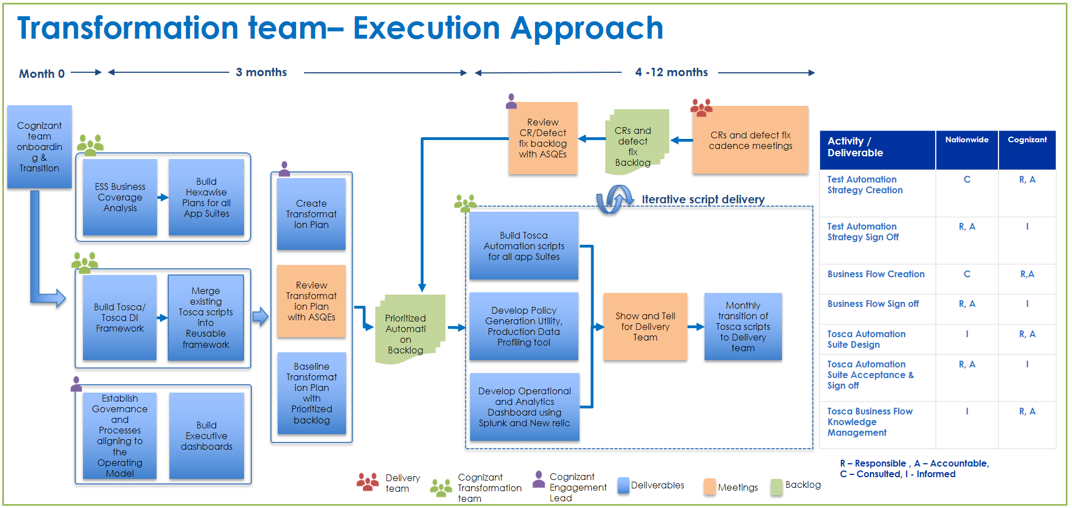

Below diagram depicts the execution approach of the delivery team:

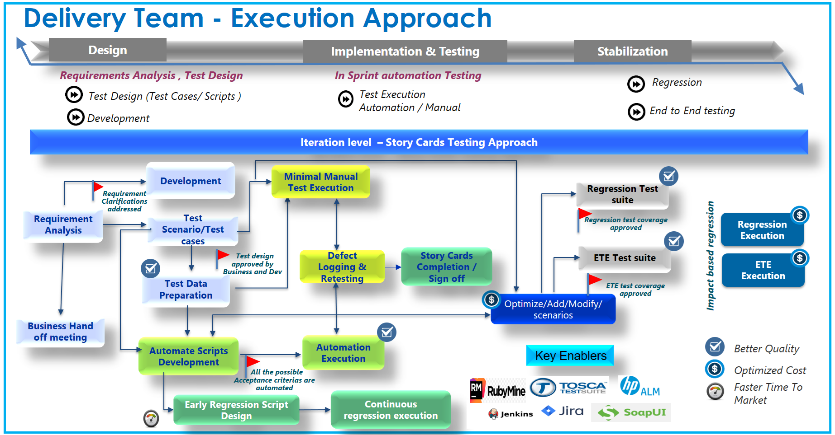
  - GOVERNANCE STRUCTURE

Cognizant will follow a robust governance structure as depicted in the below diagram:

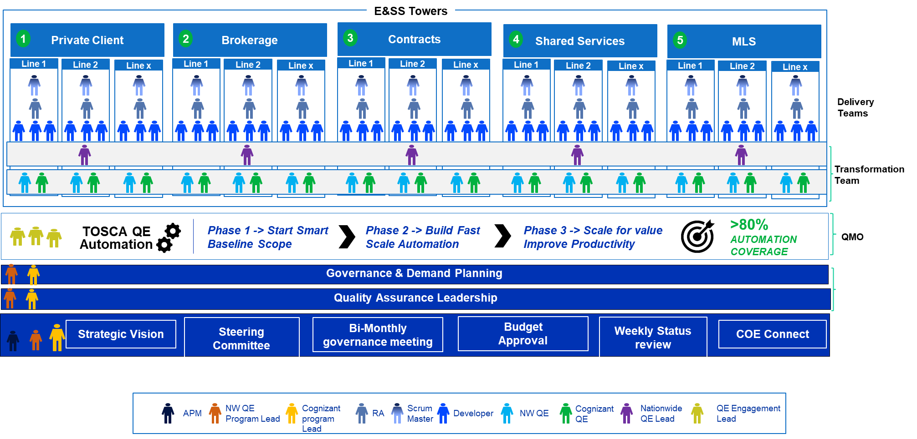

The governance follows a ‘2 in a box’ approach.

Responsibility of the teams include:
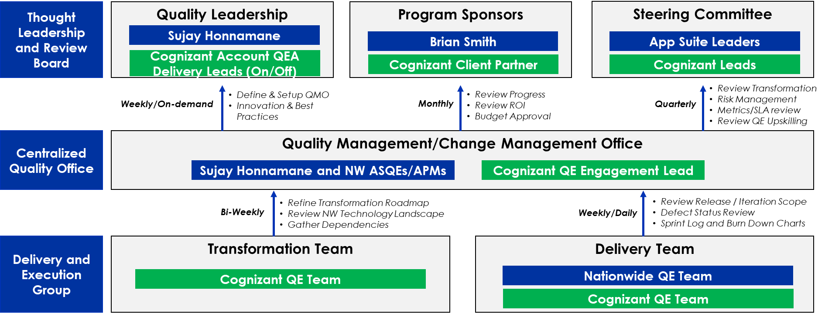

Team | Responsibility
Quality Leadership | - Define, establish performance metrics assigned to goals  - Review project scope, timelines & budget, and monitor project progress  - Manage cross team dependencies  - Identify, initiate & institutionalize process improvements  - Plan & implement changes
Program Sponsors | - Review Progress  - Review ROI  - Budget Approval
Steering Committee | - Review Transformation  - Risk Management  - Metrics/SLA review  - Review QE Upskilling
Quality Management/  Change Management Office | - Setup Governance Mechanism  - Scope and Change Management  - Transformation Management  - Review Requirements Elicitation Process  - Ensure Automation backlogs are addressed
Transformation Team | - Identify reusable assets across Product lines  - Create end to end Regression Scenarios  - Create TOSCA/TOSCA DI Automation Scripts  - Align existing TOSCA Scripts to align Framework  - Build On Demand test data solutions
Delivery Team | - Perform Release Work  - Create Iteration Tosca Automation Scripts  - Execute Automation Scripts delivered by Transformation team and provide feedback  - Metrics capturing and Defect Management

  - RISKS AND MITIGATION

Potential risks are identified at the start of the project and proposed mitigation plans are created. However, Cognizant continuously monitors the project landscape for risks arising as a result of various dynamics. The mitigation plan is tracked throughout the project, depending upon the extent of risk exposure. The identified risks are tracked and controlled at all phases of the engagement. If the risks occur and cannot be mitigated on time, then proper change control process will be initiated after discussions with Customer.

The following table details the risks and mitigation plans identified for this engagement:
Key Risks | Impact Area(s) | Mitigation Plan
Unavailability of the necessary access and infrastructure at Customer location for Cognizant personnel. | Milestones, Schedule | Commitment from Customer to provide reasonable and necessary infrastructure within reasonable time. Raising the Tosca licenses upfront for the existing team members and for the team who will be supporting the Tosca script conversion.
Availability of GIN Upgrade version in the lower environment on time to complete transformation scope | Milestones, Schedule | Commitment from Customer to provide stable environment with GIN upgrade version as soon as the version is available.
Environment unavailability | Schedule | Cognizant will work with Customer in expediting the set-up of required environments before start of the development. Any lapses beyond a reasonable quantum will be discussed with the customer for a mutual change management trigger
Non-availability of key Customer Business and IT SMEs for knowledge transition on the downstream applications and the validation steps as per the agreed plan | Lead to rework, Milestones, Schedule and Cost | Customer will Identify key SMEs upfront and secure their availability.  Customer and Cognizant shall jointly prioritize the activities in accordance with the availability of users and SMEs. For business clarification delays, Cognizant Onsite Lead will discuss with Customer’s point of contact about the impact to the Project and ensure response.
Technical challenges with automating certain business process flow in downstream applications. | Milestones, Schedule | Technical feasibility will be finalized for such flows and collaborative decision will be taken based on the analysis.

DELIVERABLES and Project Schedule

3.1 DELIVERABLES DETAILED DESCRIPTION & MILestone dates

The project deliverable timeline will follow the App suite wise iteration plan timeline, which will be defined as and when the iteration/project planning happens.

S.No. | App Suite | Deliverable Name | Description | Date
1 | Private Client | Test Scenarios / Test Cases for the Sprint | Test scenarios / functional test cases for both In Sprint and E-2-E | As per Iteration planning schedule
2 | Private Client | In Sprint Automation Scripts Development and Execution | Automation Scripts development and execution for the In Sprint User Stories | As per Iteration planning schedule
3 | Private Client | Defects Reporting & Retesting | Logging In Sprint defects and retesting as per acceptance criteria | As per Iteration planning schedule
4 | Private Client | E-2-E test execution Report | Test execution log & Defect Log for the E-2-E cases | As per Iteration planning schedule
5 | Brokerage | Test Scenarios / Test Cases for the Sprint | Test scenarios / functional test cases for both In Sprint and E-2-E | As per Iteration planning schedule
6 | Brokerage | In Sprint Automation Scripts Development and Execution | Automation Scripts development and execution for the In Sprint User Stories | As per Iteration planning schedule
7 | Brokerage | Defects Reporting & Retesting | Logging In Sprint defects and retesting as per acceptance criteria | As per Iteration planning schedule
8 | Brokerage | E-2-E test execution Report | Test execution log & Defect Log for the E-2-E cases | As per Iteration planning schedule
9 | Contract | Test Scenarios / Test Cases for the Sprint | Test scenarios / functional test cases for both In Sprint and E-2-E | As per Iteration planning schedule
10 | Contract | In Sprint Automation Scripts Development and Execution | Automation Scripts development and execution for the In Sprint User Stories | As per Iteration planning schedule
11 | Contract | Defects Reporting & Retesting | Logging In Sprint defects and retesting as per acceptance criteria | As per Iteration planning schedule
12 | Contract | E-2-E test execution Report | Test execution log & Defect Log for the E-2-E cases | As per Iteration planning schedule
13 | Shared Services | Test Scenarios / Test Cases for the Sprint | Test scenarios / functional test cases for both In Sprint and E-2-E | As per Iteration planning schedule
14 | Shared Services | In Sprint Automation Scripts Development and Execution | Automation Scripts development and execution for the In Sprint User Stories | As per Iteration planning schedule
15 | Shared Services | Defects Reporting & Retesting | Logging In Sprint defects and retesting as per acceptance criteria | As per Iteration planning schedule
16 | Shared Services | E-2-E test execution Report | Test execution log & Defect Log for the E-2-E cases | As per Iteration planning schedule
17 | MLS | Test Scenarios / Test Cases for the Sprint | Test scenarios / functional test cases for both In Sprint and E-2-E | As per Iteration planning schedule
18 | MLS | In Sprint Automation Scripts Development and Execution | Automation Scripts development and execution for the In Sprint User Stories | As per Iteration planning schedule
19 | MLS | Defects Reporting & Retesting | Logging In Sprint defects and retesting as per acceptance criteria | As per Iteration planning schedule
20 | MLS | E-2-E test execution Report | Test execution log & Defect Log for the E-2-E cases | As per Iteration planning schedule

The transformation deliverables committed as part of this SOW are defined as below:

S. No | Deliverable Name | Description | Date
1 | Transition | Non-Cognizant Vendor resource transition | 04/30/2021
2 | TOSCA / TOSCA DI Framework | Establish TOSCA/ TOSCA DI framework  Retrofit existing TOSCA scripts | 04/30/2021
3 | Hexawise driven coverage analysis | Build Hexawise plans for E2E scenarios, review with Business and baseline  Map existing scripts to scenarios | 06/02/2021
4 | Established Governance / Processes | Develop procedures, processes, templates, reusable artifacts (if any) | 04/30/2021
5 | Transformation plan | Create detailed transformation plan in sync with delivery commitment | 05/31/2021
6 | Private Client: Conversion of E-2-E regression to Tosca (30%) | Completion on 30% E-2-E Regression test script conversion from Ruby to Tosca | 08/31/2021
7 | Private Client: Conversion of E-2-E regression to Tosca (60%) | Completion on 60% E-2-E Regression test script conversion from Ruby to Tosca | 11/30/2021
8 | Private Client: Conversion of E-2-E regression to Tosca (80%) | Completion on 80% E-2-E Regression test script conversion from Ruby to Tosca | 02/28/2022
9 | Private Client: Tosca script for iteration test cases (30%) | Automation of 30% Iteration test script in Tosca | 08/31/2021
10 | Private Client: Tosca script for iteration test cases (60%) | Automation of 60% Iteration test script in Tosca | 11/30/2021
11 | Private Client: Tosca script for iteration test cases (80%) | Automation of 80% Iteration test script in Tosca | 02/28/2022
12 | Brokerage: Conversion of E-2-E regression to Tosca (80%) | Automation of 80% E-2-E Regression test script in Tosca | 08/31/2021
13 | Brokerage: Conversion of E-2-E regression to Tosca (80%) | Maintaining the automation of 80% E-2-E Regression test script in Tosca which covers all the new functionalities | 11/30/2021
14 | Brokerage: Conversion of E-2-E regression to Tosca (80%) | Maintaining the automation of 80% E-2-E Regression test script in Tosca which covers all the new functionalities | 02/28/2022
15 | Brokerage: Tosca script for iteration test cases (90%) | Automation of 90% Iteration test script in Tosca in every iteration during build | 08/31/2021
16 | Brokerage: Tosca script for iteration test cases (90%) | Automation of 90% Iteration test script in Tosca in every iteration during build | 11/30/2021
17 | Brokerage: Tosca script for iteration test cases (90%) | Automation of 90% Iteration test script in Tosca in every iteration during build | 02/28/2022
18 | Brokerage: Tosca script for Brokerage Staging (30%) | Automation of 30% Brokerage Staging test script in Tosca DI | 08/31/2021
19 | Brokerage: Tosca script for Brokerage Staging (60%) | Automation of 60% Brokerage Staging test script in Tosca DI | 11/30/2021
20 | Brokerage: Tosca script for Brokerage Staging (80%) | Automation of 80% Brokerage Staging test script in Tosca DI | 02/28/2022
21 | Contract: Conversion of E-2-E regression to Tosca (30%) | Completion on 30% E-2-E Regression test script conversion from Ruby to Tosca | 08/31/2021
22 | Contract: Conversion of E-2-E regression to Tosca (60%) | Completion on 60% E-2-E Regression test script conversion from Ruby to Tosca | 11/30/2021
23 | Contract: Conversion of E-2-E regression to Tosca (80%) | Completion on 80% E-2-E Regression test script conversion from Ruby to Tosca | 02/28/2022
24 | Contract: Tosca script for Contract Staging (30%) | Automation of 30% Contract Staging test script in Tosca DI | 08/31/2021
25 | Contract: Tosca script for Contract Staging (60%) | Automation of 60% Contract Staging test script in Tosca DI | 11/30/2021
26 | Contract: Tosca script for Contract Staging (80%) | Automation of 80% Contract Staging test script in Tosca DI | 02/28/2022
27 | Shared Services: Conversion of E-2-E regression to Tosca (30%) | Completion on 30% E-2-E Regression test script conversion from Ruby to Tosca | 08/31/2021
28 | Shared Services: Conversion of E-2-E regression to Tosca (60%) | Completion on 60% E-2-E Regression test script conversion from Ruby to Tosca | 11/30/2021
29 | Shared Services: Conversion of E-2-E regression to Tosca (80%) | Completion on 80% E-2-E Regression test script conversion from Ruby to Tosca | 02/28/2022
30 | Shared Services: Tosca script for iteration test cases (30%) | Automation of 30% Iteration test script in Tosca | 08/31/2021
31 | Shared Services: Tosca script for iteration test cases (60%) | Automation of 60% Iteration test script in Tosca | 11/30/2021
32 | Shared Services: Tosca script for iteration test cases (80%) | Automation of 80% Iteration test script in Tosca | 02/28/2022
33 | MLS: Conversion of E-2-E regression to Tosca (30%) | Completion on 30% E-2-E Regression test script conversion from Ruby to Tosca | 08/31/2021
34 | MLS: Conversion of E-2-E regression to Tosca (60%) | Completion on 60% E-2-E Regression test script conversion from Ruby to Tosca | 11/30/2021
35 | MLS: Conversion of E-2-E regression to Tosca (80%) | Completion on 80% E-2-E Regression test script conversion from Ruby to Tosca | 02/28/2022
36 | Implementation of Policy Generation utility for the ES&S area for the LOBs mentioned in Scope Section | Implementation of Policy Generation utility (test data entry) based on the business rules for the LOBs | 11/30/2021
37 | Implementation of Production Data Profiling tool | Implementation of Production Data Profiling tool for policy variations | 12/31/2021
38 | Implementation of Rocketchat /Microsoft teams integrated bots(Self-service test data needs) | Customization and Implementation of Rocketchat /Microsoft teams integrated bots(Self-service test data needs) for the ES&S area | 02/28/2022
39 | Implementation of Splunk/New Relic Dashboards | Implement Splunk and New Relic dashboards for analytics | 1/31/2022
40 | Implementation of Defect Predictor / Requirement Validator BOT | Implement Defect Predictor / Requirement Validator BOT as needed | 02/28/2022

SERVICE LEVEL AGREEMENTS
This section sets forth Key Performance Indicators (KPIs) against which the performance will be measured. The Defect Leakage% in Production SLA will be baselined during the first 9 months of the engagement. After the KPI baselining, Customer and Cognizant will jointly discuss and decide on converting these KPIs to SLA depending on the maturity of this delivery model. The KPI measurement and tracking process will be defined during the first two months of starting the engagement and will be updated in the Test Plan.

Sl # | Name | Formula & Target | Measurement Frequency | Key Dependency Indicators(KDIs)
1 | Defect Leakage % in Production | ((Number of Severity 1&Severity 2 defects found in Production and ‘Missed by Cognizant QA‘) / (Number of defects of all Severities found by Cognizant QA + Number of defects of all Severities found in Production and ‘Missed by Cognizant QA’))*100 | After Warranty period of each release (60 days after Go live date) | Key Dependency Indicators (KDI’s) which influence this KPI are:  • Any requirement change is made prior to the code delivery to QA or prior to the Stabilization Phase  • Quality of Code Drop (First Pass) should be within the defined limit of 80%  • Quality of defect fix (based on defect reopen and new regression defect) should be within the defined limit of 95%  • Test Environment Availability of more than 95% of the time during execution  • All defects are fixed as per the defined KPIs (as defined in Test Plan document)  • All dependent activities (like code drop, DDIT of downstream applications) are completed as per the agreed plan date  • Definition of defect severity as defined in Test Plan document  • Defect RCA and the leakage contribution team to be jointly and agreed upon
Along with the above SLA, the KPI measurement and tracking will be done for the ‘Automation Coverage’ as per the details below.
Sl # | Name | Formula & Target | Measurement Frequency | Key Dependency Indicators(KDIs)
1 | Automation Coverage | (Total number of test cases automated/ Total number of test cases automatable) * 100  Target as per the table provided in section 1.3.1 (Project Scope) | As per the timeline provided in section 1.3.1 | Key Dependency Indicators (KDI’s) which influence this KPI are:  • Any requirement change is made prior to the code delivery to QA or prior to the Stabilization Phase  • Quality of Code Drop (First Pass) should be within the defined limit of 80%  • Quality of defect fix (based on defect reopen and new regression defect) should be within the defined limit of 95%  • Test Environment Availability of more than 95% of the time during script development & dry-run execution  • Tosca licenses for 80% of the resources  • Tosca DI licenses for 20% of the resources  • Same level of Automation of User Stories assigned to Customer

PENALTY:
Supplier and Customer will agree to a maximum risk amount of 5% of the monthly invoice amount. In the event if the supplier does not meet any one of the above mentioned service levels: Defect Leakage % in Production and Automation Coverage, the customer will withhold this amount from the payment milestone amount to the supplier.
Defect Leakage % in Production SLA will be baselined during the first 9 months of the engagement and hence the SLA and Penalty will not be applicable during the first 9 months for Defects Leakage %
Automation Coverage SLA will be calculated as per the targets provided in Section 1.3.1 after the proper RCA has been performed on all production defects upon agreement between supplier and customer

SPECIFICATION AND REQUIREMENTS
- Tosca license for 80% of the resources
- Tosca VDIs are required for execution for 30% of the resources
- TOSCA DI Licenses for 20% of the resources
- Dedicated QA Test Environment(s) are required, and Cognizant will submit necessary environments as part of the transformation roadmap

Assumptions and dependencies

ASSUMPTIONS:
- Cognizant will utilize Hexawise tool to identify optimized scenarios, which will be considered for test coverage during System/System integration testing phases.
- Customer will provide access to Hexawise tool, JIRA, ALM, Jenkins/Concourse and all necessary softwares, SharePoint and workspace repository for project demands.
- Customer Business/ IT stakeholders to review optimized E2E scenarios and provide signoff
- Customer to provide dedicated environment for transformation team
- Customer to support deployment of latest code drops in dedicated environment
- Cognizant will govern the Onsite and Offshore QEA resources deployment and adjust the onsite & offshore head count based on the business demand.
- Upon completion of the script development dry run, transformation team will hand over the scripts to the delivery team. Any maintenance activity will be taken care by the delivery team.

DEPENDENCIES:

People:
- Customer team to share the requirement documents and test artifacts available for the applications in scope.
- Availability of Non-Cognizant vendor resources/Customer SMEs to provide KT in the applications where Non-Cognizant vendor resources are working. Customer will be facilitating the KT sessions
- Availability of the Customer stakeholders for reviews, show & tells
Process:
- TSB approval for BOTs implementation

Tools/Infrastructure:
- Customer to provide licenses/ access for HP ALM/ JIRA, SoapUI, Postman, Jenkins/Concourse, ETL DB, Informatica and Hexawise tools.
- Customer needs to provide support for any TOSCA product version changes, DLL file addition, new TOSCA features and additional support required from Tricentis
- Availability and access of the software required for implementation of the Rocketchat /Microsoft teams integrated BOT, Policy Generation utility, Production Data Profiling tool and other Defect Predictor/Requirement Validator Bots
- VDE/ID creation for the Transformation team and additional resources added to delivery team
- Availability of stable upgraded GIN version in lower QA Environment by end of April.

Responsibilities
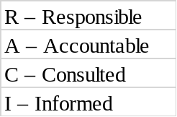

Transformation Team:
Phase | Activity/ Deliverable | Customer | Cognizant
Testing | TOSCA tool license, environment access | R, A | C, I
Testing | Jenkins/Concourse Setup on VDI for continuous Integration | C, I | R, A
Testing | Test Automation Strategy Creation | C | R, A
Testing | Test Automation Strategy Sign Off | R, A | I
Testing | Business Flow Creation using Hexawise | C | R, A
Testing | Business Flow Sign Off | R, A | I
Testing | TOSCA Automation Suite Design and test data setup | I | R, A
Testing | TOSCA Automation Suite Acceptance & Sign Off | R, A | I
Testing | Test Execution Report / Status Report | C, I | R, A
Testing | TOSCA Business Flow Knowledge Management | I | R, A
Testing | SLA/KPI Reporting | C, I | R, A
Testing | Demand Management | R, A | C, I
Testing | Automation Artifacts / Repo & SharePoint knowledge transfer to Delivery team | C, I | R, A
Testing | Knowledge transfer to Delivery team on TOSCA scripts maintenance & execution | C, I | R, A
Testing | Tosca Mentoring & Coaching to Delivery team/Customer QEs | C, I | R, A

Delivery Team (for Cognizant scope of work):
Phase | Activity/ Deliverable | Customer | Cognizant
Testing | TOSCA & Ruby Mine tool license, environment access | R, A | C, I
Testing | Jenkins/Concourse Setup on VDI for continuous Integration | C, I | R, A
Testing | Test Data setup | C, I | R, A
Testing | Functional Test Scenarios / Test Case Preparation | C, I | R, A
Testing | Automated Test Scripts Development | C, I | R, A
Testing | Automation Test Scripts Debugging | I | R, A
Testing | Functional Test Cases/ Test Scripts Review & Sign Off | R, A | C, I
Testing | Functional Test Execution Report / Status Report | C, I | R, A
Testing | Defect Tracking / Defect Retesting | C, I | R, A
Testing | Non-Functional Testing – Security/Accessibility | C, I | R, A
Testing | Non-Functional Testing – Performance | R, A | C, I
Testing | Defect Triaging | R, A | C, I
Testing | TOSCA Business Flow Knowledge Management Update | C, I | R, A
Testing | Automation Artifacts / Repo & SharePoint Updates | C, I | R, A
Testing | Knowledge transfer on scripts maintenance & execution | C, I | R, A
Testing | Tosca Mentoring & Coaching | C, I | R, A
Testing | SLA/KPI Reporting | C, I | R, A
Testing | Demand Management | R, A | C, I
Testing | Sprint Planning | R, A | C, I
Testing | Testing Team Show & Tell and Sign Off the Story cards | C, I | R, A

Supplier’S RESPONSIBILITIES
Supplier will be responsible for the following in addition to the deliverables defined above:
- To share a weekly status report based on the mutually agreed template with Customer, which will share the present work status, issues and track dependencies to closure
- Will follow Customer technical standards and best practices during automation scripts development
- Will support knowledge transfer back to Customer during the project in terms of Show and Tell

Customer’S RESPONSIBILITIES
Please refer mentioned in Section 4 above.
Customer will be responsible for the following:
- Provide a single point of contact to coordinate the activities with other stakeholders/groups, and identify the key stakeholders and SMEs to be involved
- Provide necessary inputs and sign off on required project documents
- Customer to ensure agreed capacity work is provided for the Delivery team
- Upon providing the automation scripts to delivery team, customer to review and provide sign-off
- Provide the identified functional and technical SMEs for consultation and review support for each code merge to resolve merge conflicts as per the agreed timelines
- Ensure availability of relevant stakeholders and SMEs from Customer during the duration of the project for responding to any clarifications that are sought.
- Provide necessary feed files/documents from upstream and downstream systems during System integration, end to end and regression testing phases.
- Provide necessary hardware and software required for the Execution Phase
- Provide access to development and test environments deemed necessary for the Execution Phase
- Ensure timely resolution of queries/issues and dependencies raised by Supplier team to the concerned impacted teams so that the project schedule does not get impacted
- Provide support for any change controls arising during the project execution Review meetings
- User story delivery & automation by the Customer FTEs as per the plan

Mutual Responsibilities
Please refer mentioned in Session 4 above.

PROGRESS MEETINGS
Please refer to Section 2.2.

4.3.2 KNOWLEDGE TRANSFER
As part of regular transition to delivery teams, respective Knowledge Management artifacts will be transitioned

STAFFING SCHEDULE
Supplier will continue with the current delivery team. Changes to the core team are at the supplier’s sole discretion but will not be reasonably withheld due to life changing events, promotions, new Supplier resources, or planned roll-offs. These situations must be communicated to Customer immediately upon Supplier's knowledge and a mutually agreeable resolution will be reached. We will bring new team for the transformation activities.

Cognizant and customer agreed on the below core team size:
Monthly Core team effort in | Current Status | Upto 9 months | 10-12 months | 13-18 months | 19-24 months | 25-36 months
Person Month | 38 | 38 | 35 | 34 | 33 | 33
Person Hours | 6080 | 6080 | 5600 | 5440 | 5280 | 5280
The baselined effort as described in the above table is considered as the Core Team. Customer will ensure the work demand for the committed core team for the entire duration of the SOW.
The Team distribution across App Suites for the next 3 years will be:
 | Monthly Core Team Size (in Person Months) **
 | Current Status | Till 9 months | 10-12 months | 13-18 months | 19-24 months | 25-36 months
Private Client | 12 | 12 | 11 | 11 | 11 | 11
Brokerage | 7 | 7 | 7 | 6 | 6 | 6
Contract | 13 | 13 | 12 | 12 | 11 | 11
Shared Services | 1 | 1 | 1 | 1 | 1 | 1
MLS | 5 | 5 | 4 | 4 | 4 | 4

** Resource movement within App Suites can be handled based on the demand, provided the total capacity and application are same/ not altered.
Four weeks will be planned for knowledge transition from non-Cognizant vendor resources to Cognizant resources.
If required by the end of the 2nd week of the transition, Cognizant may request for additional 4 weeks of transition from non-Cognizant vendor resources
Any change in demand will be considered as additional effort and a core-flex model will be followed. The below Demand Management process & Flex-to-Core conversion process will be followed. Change request will be initiated for both the cases.

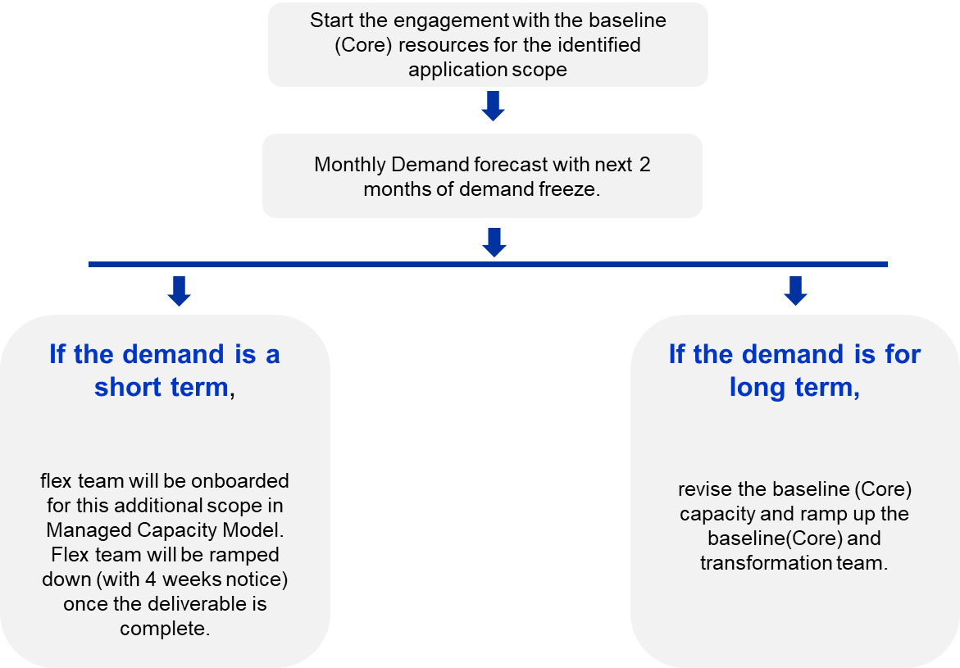

ACCEPTANCE and approval CRITERIA
- Customer shall inspect all deliverables that supplier develops under this SOW. Supplier shall inform Customer of the dates for all inspections/reviews and provide draft copies of the deliverable subject to inspection/review within a mutually agreed upon timeframe before the inspection/review meeting. Customer has the right to participate in these inspections and to review the results of the inspections. Supplier shall document, track, and resolve all material issues resulting from the inspections within mutually agreed upon time frame.
- Supplier and Customer will define the appropriate escalation path for issues related to the acceptance of the deliverables during the first month of the engagement.
- Customer will provide written statement of acceptance or non-conformity notice within the mutually agreed upon timeframe of the receipt of the Deliverable. If no timeframe is agreed by the Parties, then the default timeframe shall be 5 business days from the inspection meeting or receipt of the Deliverable whichever is later, after which Cognizant will escalate. The acceptance of the deliverable will follow the clause as mentioned in the MSA.

change Management
Any changes to the scope or schedule over the course of the project will be handled according to the Change Control Procedures outlined below. The change requests can be initiated either by Cognizant team or by Customer team.
The total scope of work for the project is defined in this SOW that will be signed off by Customer before project commencement. A CR can only be implemented when mutually agreed upon between Cognizant and Customer. The figure below represents the work-flow of a change request:

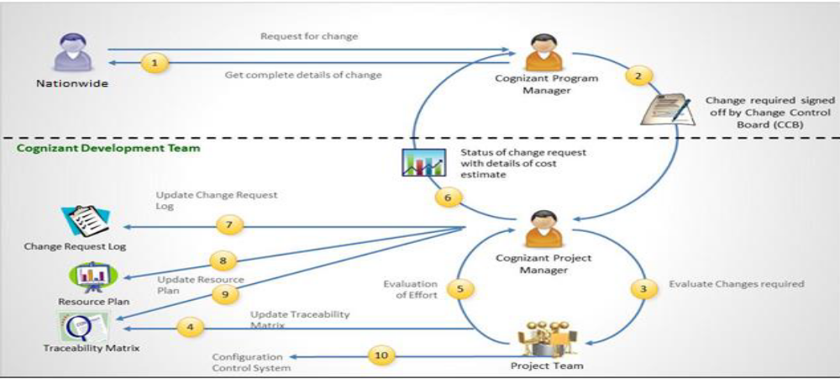
The table below provides the steps for the change management process:
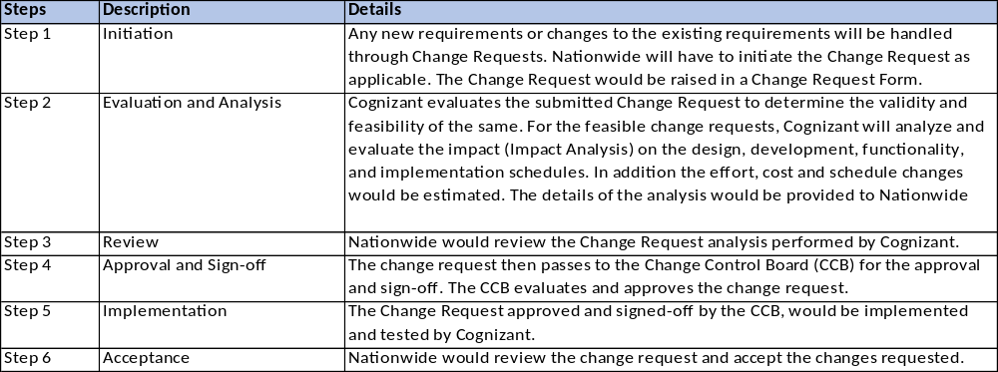

Change Request will be invoked if any of the following scenarios occur:
- If there is any need or request to increase the BOT licenses beyond the agreed licenses of one perpetual license for each of the BOTs (Defect Predictor & Requirement Validator BOTs)
- Addition of Flex team beyond the Core Team for a short term (<3 months)
- Core Team expansion due to additional demand/ program rollouts
- Any other external factors not in control of Cognizant and impacts delivery / schedule

Payment Schedule
Cognizant will invoice Customer on a monthly basis as per the schedule below for the core team. The payment model will start from 1st of March 2021 for a period of 36 months through 29th February 2024.

The Monthly cost distribution across App Suites for the next 3 years will be as below:

 | Mar’21  (1 Month) ** | Apr’21  (1 Month) ** | May’21 – Nov’21  (7 Months) | Dec’21 – Feb’22  (3 Months) | Mar’22 – Aug’23 (6 Months) | Sep’22- -Feb’23 (6 Months) | Mar’23 – Feb’24 (12 Months)
Private Client | $66,960 | $75,408 | $75,408 | $69,168 | $66,720 | $66,720 | $66,720
Brokerage | $32,400 | $38,272 | $38,272 | $36,672 | $31,200 | $31,200 | $31,200
Contract | $61,200 | $64,818 | $72,498 | $72,498 | $70,560 | $66,720 | $58,560
Shared Services | $4,320 | $4,368 | $4,368 | $4,248 | $3,840 | $3,840 | $3,840
MLS | $21,600 | $21,704 | $21,704 | $16,584 | $15,360 | $15,360 | $15,360

** Cognizant will not charge Nationwide for the entire KT cost for the month of March for offshore resources and KT cost for offshore resources for April for Contract Tower

Monthly Payment Milestone is as below:-
S. No | Milestone | Monthly Resource Load in PM | Date | Amount
1 | March-21 | 38 | 31-Mar-21 | $186,480
2 | April-21 | 38 | 30-Apr-21 | $204,570
3 | May-21 | 38 | 31-May-21 | $212,250
4 | June-21 | 38 | 30-Jun-21 | $212,250
5 | July-21 | 38 | 31-Jul-21 | $212,250
6 | August-21 | 38 | 31-Aug-21 | $212,250
7 | September-21 | 38 | 30-Sep-21 | $212,250
8 | October-21 | 38 | 31-Oct-21 | $212,250
9 | November-21 | 38 | 30-Nov-21 | $212,250
10 | December-21 | 35 | 31-Dec-21 | 199,170
11 | January-22 | 35 | 31-Jan-22 | 199,170
12 | February-22 | 35 | 28-Feb-22 | 199,170
13 | March-22 | 34 | 31-Mar-22 | $187,680
14 | April-22 | 34 | 30-Apr-22 | $187,680
15 | May-22 | 34 | 31-May-22 | $187,680
16 | June-22 | 34 | 30-Jun-22 | $187,680
17 | July-22 | 34 | 31-Jul-22 | $187,680
18 | August-22 | 34 | 31-Aug-22 | $187,680
19 | September-22 | 33 | 30-Sep-22 | $183,840
20 | October-22 | 33 | 31-Oct-22 | $183,840
21 | November-22 | 33 | 30-Nov-22 | $183,840
22 | December-22 | 33 | 31-Dec-22 | $183,840
23 | January-23 | 33 | 31-Jan-23 | $183,840
24 | February-23 | 33 | 28-Feb-23 | $183,840
25 | March-23 | 33 | 31-Mar-23 | $175,680
26 | April-23 | 33 | 30-Apr-23 | $175,680
27 | May-23 | 33 | 31-May-23 | $175,680
28 | June-23 | 33 | 30-Jun-23 | $175,680
29 | July-23 | 33 | 31-Jul-23 | $175,680
30 | August-23 | 33 | 31-Aug-23 | $175,680
31 | September-23 | 33 | 30-Sep-23 | $175,680
32 | October-23 | 33 | 31-Oct-23 | $175,680
33 | November-23 | 33 | 30-Nov-23 | $175,680
34 | December-23 | 33 | 31-Dec-23 | $175,680
35 | January-24 | 33 | 31-Jan-24 | $175,680
36 | February-24 | 33 | 29-Feb-24 | $175,680
Total |  |  |  | $6,811,590

The cost above is for the core team only. The cost assumes optimization due to year on year productivity improvement. Same capacity will be achieved with transformation levers and hence reduction of cost and monthly resource load.

Any additional capacity requirement beyond the scope will be considered as Flex Team and will follow the CR process. Invoicing of the Flex team will be done on monthly basis for the additional Person Month added for the month and MSP rate cards will be used for the calculation of the cost. The Flex Team will be handled separately as part of the MCA project and outside of this SOW.

Termination Charges:
If Customer intends to terminate the agreement, Customer will have to pay the termination charges as provided in the below table. The termination will be effective on a month end and Customer will have to pay the monthly invoice amount along with the termination charges. Minimum 2 weeks’ notice to be provided to Cognizant for termination of the agreement.

Termination Timeline | Termination Charges
1-12 Months | $280,000
13-24 Months | $150,000
25-30 Months | $75,000
31-36 Months | No Charges

Appendix
NA

